Balancing Performance, Accuracy, and

Precision for Secure Cloud Transactions

INTRODUCTION:

Cloud computing has recently emerge (come into view) as a computing paradigm in which storage and computation (calculation) can be outsourced from organizations to next generation data centers hosted. In this paper to provide scalability and elasticity (flexibility), cloud services often make heavy use of replication to ensure consistent performance and availability this consistency model is a variant of weak consistency that allows data to be inconsistent among some replicas during the update process, but ensures that updates will eventually be propagated to all replicas. This makes it difficult to strictly maintain the ACID guarantees; consistency part of ACID is sacrificed to provide reasonable availability Interesting consistency problems can arise as transactional database systems are deployed in cloud environments and use policy-based authorization systems to protect sensitive resources.

SCOPE OF THE PROJECT
In this project, what we achieving to give the user more secure transaction as possible And also the notion of trusted transactions when dealing with proofs of authorization. Accordingly, we propose several increasingly stringent levels of policy consistency constraints, and present different enforcement approaches to guarantee the trustworthiness of transactions executing on cloud servers

LITERATURE SURVEY

TITLE : Building Castles out of Mud: Practical Access Pattern Privacy and Correctness on Untrusted Storage

AUTHOR : Zhi-Dan Zhao, Lei Rao, Xue Liu

YEAR : Feb. 2013.
DESCRIPTION
We introduce a new practical mechanism for remote data storage with efficient access pattern privacy and correctness. A storage client can deploy this mechanism to issue encrypted reads, writes, and inserts to a potentially curious and malicious storage service provider, without revealing information or access patterns. The provider is unable to establish any correlation between successive accesses, or even to distinguish between a read and a write. Moreover,
the client is provided with strong correctness assurances for its operations – illicit provider behavior does not go undetected. We built a first practical system – orders of magnitude faster than existing implementations – that can execute over several queries per second on 1Tbyte+ databases with full computational privacy and correctness.

TITLE : HAIL: A High-Availability and Integrity Layer for Cloud Storage
AUTHOR : Xiwang Yang, Yang Guo, and Yong Liu

YEAR : May 2012.
DESCRIPTION
We introduce HAIL (High-Availability and Integrity Layer), a distributed cryptographic system that permits a set of servers to prove to a client that a stored file is intact and retrievable. HAIL strengthens, formally unifies, and streamlines distinct approaches from the cryptographic and distributed-systems communities. Proofs in HAIL are efficiently computable by servers and highly compact typically tens or hundreds of bytes, irrespective of file size. HAIL cryptographically verifies and reactively reallocates file shares. It is robust against an active, mobile adversary, i.e., one that may progressively corrupt the full set of servers. We propose a strong, formal adversarial model for HAIL, and rigorous analysis and parameter choices. We
show how HAIL improves on the security and efficiency of existing tools, like Proofs of Irretrievability (PORs) deployed on individual servers. We also report on a prototype implementation

TITLE : Provable Data Possession at Untrusted Stores∗

AUTHOR : Stavros Giuseppe Ateniese,Randal Burns, Reza Curtmola

YEAR : mar 2012.

DESCRIPTION
We introduce a model for provable data possession (PDP) that allows a client that has stored data at an un trusted server to verify that the server possesses the original data without retrieving it. The model generates probabilistic proofs of possession by sampling random sets of blocks from the server, which drastically reduces I/O costs. The client maintains a constant amount of metadata to verify the proof. The challenge/response protocol transmits a small, constant amount of data, which minimizes network communication. Thus, the PDP model for remote data checking supports large data sets in widely-distributed storage systems. We present two provably-secure PDP schemes that are more efficient than previous solutions, even when compared with schemes that achieve weaker guarantees. In particular, the overhead at the server is low (or even constant), as opposed to linear in the size of the data. Experiments using our implementation verify the practicality of PDP and reveal that the performance of PDP is bounded by disk I/O and not by cryptographic computation.

TITLE : Consistency Rationing in the Cloud: Pay only when it matters
AUTHOR : Kleanthi Lakiotaki1, Nikolaos F. Matsatsinis and Alexis

YEAR : oct 2011
DESCRIPTION
Cloud storage solutions promise high scalability and low cost. Existing solutions, however, differ in the degree of consistency they provide. Our experience using such systems indicates that there is a non-trivial trade-off between cost, consistency and availability. High consistency implies high cost per transaction and, in some situations, reduced availability. Low consistency is cheaper but it might result in higher operational cost because of, e.g., overselling of products in a Web shop. In this paper, we present a new transaction paradigm, that not only allows designers to define the consistency guarantees on the data instead at the transaction level, but also allows to automatically switch consistency guarantees at runtime. We present a number of techniques that let the system dynamically adapt the consistency level by monitoring the data and/or gathering temporal statistics of the data. We demonstrate the feasibility and potential of the ideas through extensive experiments on a first prototype implemented on Amazon’s S3 and running the TPC-W benchmark. Our experiments indicate that the adaptive strategies presented in the paper
result in a significant reduction in response time and costs including the cost penalties of inconsistencies.
TITLE : Relaxed Currency and Consistency: How to Say “Good Enough” in SQL
AUTHOR : Hongfei Guo, Per-Åke Larson
YEAR : mar 2011.

DESCRIPTION
Despite the widespread and growing use of asynchronous copies to improve scalability, performance and availability, this practice still lacks a firm semantic foundation. Applications are written with some understanding of which queries can use data that is not entirely current and which copies are “good enough”; however, there are neither explicit requirements nor guarantees. We propose to make this knowledge available to the DBMS through explicit currency and consistency (C&C) constraints in queries and develop techniques so the DBMS can guarantee that the constraints are satisfied. In this paper we describe our model for expressing
C&C constraints, define their semantics, and propose SQL syntax. We explain how C&C constraints are enforced in MT Cache, our prototype mid-tier database cache, including how constraints and replica update policies are elegantly integrated into the cost-based query optimizer. Consistency constraints are enforced at compile time while currency constraints are enforced at run time by dynamic plans that check the currency of each local replica before use and select sub-plans accordingly. This approach makes optimal use of the cache DBMS while at the same time guaranteeing that applications always get data that is "good enough" for their
purpose.

TITLE : Enforcing Policy and Data Consistency of Cloud
Transactions
AUTHOR : Badrul Sarwar, George Karypis, Joseph Konstan, and John Riedl.

YEAR : jun 2010.
DESCRIPTION
In distributed transactional database systems deployed over cloud servers, entities cooperate to form proofs of authorizations that are justified by collections of certified credentials. These proofs and credentials may be evaluated and collected over extended time periods under the risk of having the underlying authorization policies or the user credentials being in inconsistent states. It therefore becomes possible for a policy-based authorization systems to make unsafe decisions that might threaten sensitive resources. In this paper, we highlight the criticality of the problem. We then present the first formalization of the concept of trusted transactions when dealing with proofs of authorizations. Accordingly, we define different levels of policy consistency constraints and present different enforcement approaches to guarantee the trustworthiness of transactions executing on cloud servers. We propose a Two-Phase Validation
Commit protocol as a solution, that is a modified version of the basic Two-Phase Commit protocols. We finally provide performance analysis of the different presented approaches to
guide the decision makers in which approach to use.

TITLE : Above the Clouds: A Berkeley View of Cloud
Computing
AUTHOR : Michael Isard, Mihai Budiu.
YEAR : jan 2010.
DESCRIPTION
Cloud Computing, the long-held dream of computing as a utility, has the potential to transform a large part of the IT industry, making software even more attractive as a service and shaping the way IT hardware is designed and purchased. Developers with innovative ideas for new Internet services no longer require the large capital outlays in hardware to deploy their service or the human expense to operate it. They need not be concerned about over provisioning for a service whose popularity does not meet their predictions, thus wasting costly resources, or under provisioning for one that becomes wildly popular, thus missing potential customers and revenue. Moreover, companies with large batch-oriented tasks can get results as quickly as their programs can scale, since using 1000 servers for one hour costs no more than using one server for 1000 hours. This elasticity of resources, without paying a premium for large scale, is unprecedented in the history of IT.

MODULES
- User interface
- Quality of service
- Authorization policies
- Distributed transactions
- Certificate Authorities

MODULE DESCRIPTION

User Interface Design:
To connect with server user must give their username and password then only they can able to connect the server. If the user already exits directly can login into the server else user must register their details such as username, password and Email id, into the server. Server will create the account for the entire user to maintain upload and download rate. Name will be set as user id. Logging in is usually used to enter a specific page.

Quality Of Service
In this module, the data is given by customer requests arrive at each front-end proxy (alternative) server. After the receiving the data it sense automatically to check the whether the server the total number of Server. And it based upon dynamically generated DNS responses, HTTP redirections, or using persistent HTTP proxies to tunnel requests. We assume that there exists a proxy/DNS server collocated with each request source.

Authorization Policies
In this model, once user add the document in the cloud server and its compute the file and also analysis the user. It’s also analysis file belong to which category and pass the file in to particular database in cloud environment.

Distributed Transactions
In this model we going to get value from authorization model and we will store the data in particular cloud database in cloud environment using transaction management in the system. Transaction management used for safe transaction process in file transfer system. It’s using a commit or rollback in transaction system.

Certificate Authorities
In this model we are going to analysis the file transfer system are monitor by a third party person. See entire transaction those who are pass the file in cloud they are file are belong to the particular database or un wanted are store in any database.

MODULES DIAGRAM
User interface 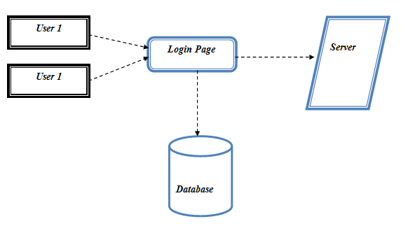
Quality Of Service

USER
TEMPOARY STORAGE
QOS
Server 1
Server 2

Authorization Policies

USER
File
Analyzer
Analytic Hierarchy Process
Output

Distributed Transactions:

USER
File
Authorization
Policies

OUTPUT
Transaction protocol
Atomic protocol

Certificate Authorities:

USER
FILE
Uploading
Authorization
Policies

OUTPUT
CA System

GIVEN INPUT EXPECTED OUTPUT

User Interface:
Given Input : Create node and set name, Ip, port for that node.
Output : Nodes are created and displayed.

Quality of service

Given Input : The data is given by customer requests arrive at each front-end proxy server.
Output : It passes to the data base.

Authorization policies

Given Input : Given Data from user.
Output : It calculates the keyword length.

Distributed Transactions:
Given Input : User requirement from Data.
Output : To Store value in cloud Database.

Certificate Authorities:

Given Input : User requirement and distributed transaction
Output : The data are verified by third party.

TECHNIQUE USED
Two-Phase Validation Commit protocol
Definition:
The two-phase commit protocol (2PC) is a type of atomic commitment protocol (ACP). It is a distributed algorithm that coordinates all the processes that participate in a distributed atomic transaction on whether to commit or abort (roll back) the transaction (it is a specialized type of consensus protocol). The protocol achieves its goal even in many cases of temporary system failure (involving process, network node, communication, etc. failures), and is thus widely utilized. However, it is not resilient to all possible failure configurations, and in rare cases user (e.g., a system's administrator) intervention is needed to remedy an outcome.

HARDWARE & SOFTWARE REQUIREMENTS

HARDWARE
PROCESSOR : PENTIUM IV 2.6 GHz, Intel Core 2 Duo.
RAM : 512 MB DD RAM
MONITOR : 15” COLOR
HARD DISK : 40 GB

SOFTWARE
Front End : JAVA (JSP, SERVLET), HIBERNATE.
Back End : My SQL 5.5
Operating System : Windows XP/07
IDE : Eclipse

USE CASE DIAGRAM

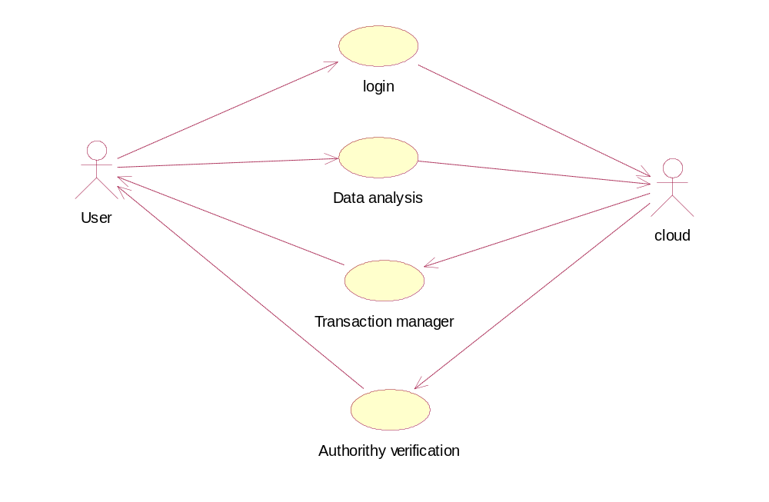

This is a type of behavioral diagram defined by and created from a Use-case analysis. Here a sender can send a packet it selects a dynamic path routing and then it send to receiver node and then if attacker is received .They may be send or drop the packet. Thus here nodes and attacker is an actor. The packet may be sent or may not be sent. In this UML diagram we present a actor behavior or role in that project.

CLASS DIAGRAM

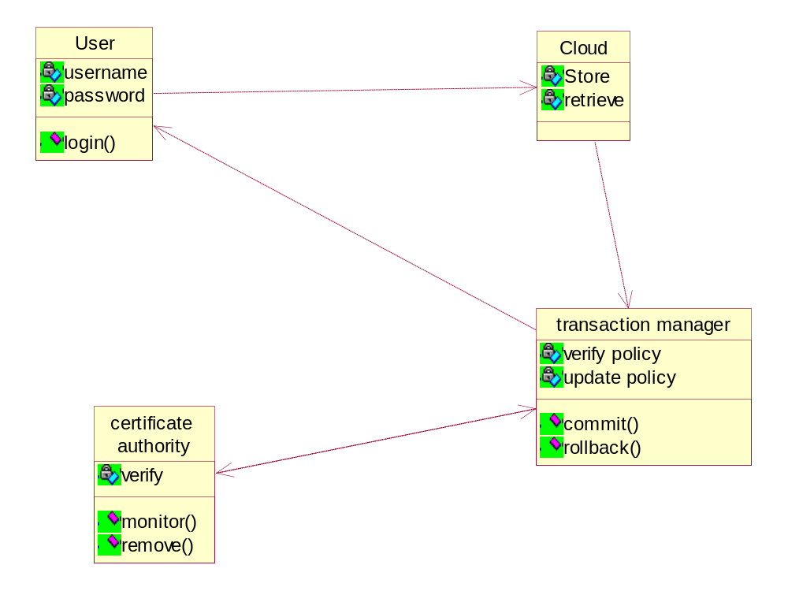

This type of static structure diagram that describes the structure of a system by showing the system’s classes, their attributes, operations (or methods), and the relationships among the classes. Here the node consists of ip address, port no, name. And then attacker also has same things. Then we find out the attacker and then predict our network.

OBJECT DIAGRAM

Query
Atomic protocol

Cloud
2pvc
Result

An Object diagram focuses on some particular set of object instances and attributes, and the links between the instances. Here we create an object for node selection and attacker node for receiving and sending.

SEQUENCE DIAGRAM

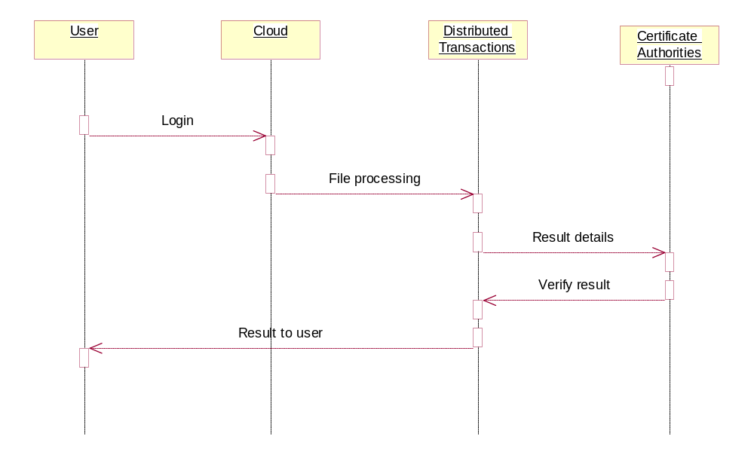

This diagram shows how processes operate with one another and in what order. In this project source node find a destination by using dynamic routing if an attacker interrupts in that node they send a positive reply and malicious may be send to destination node. And then by an alert message broadcast to all nodes about attacker.

COLLABORATION DIAGRAM

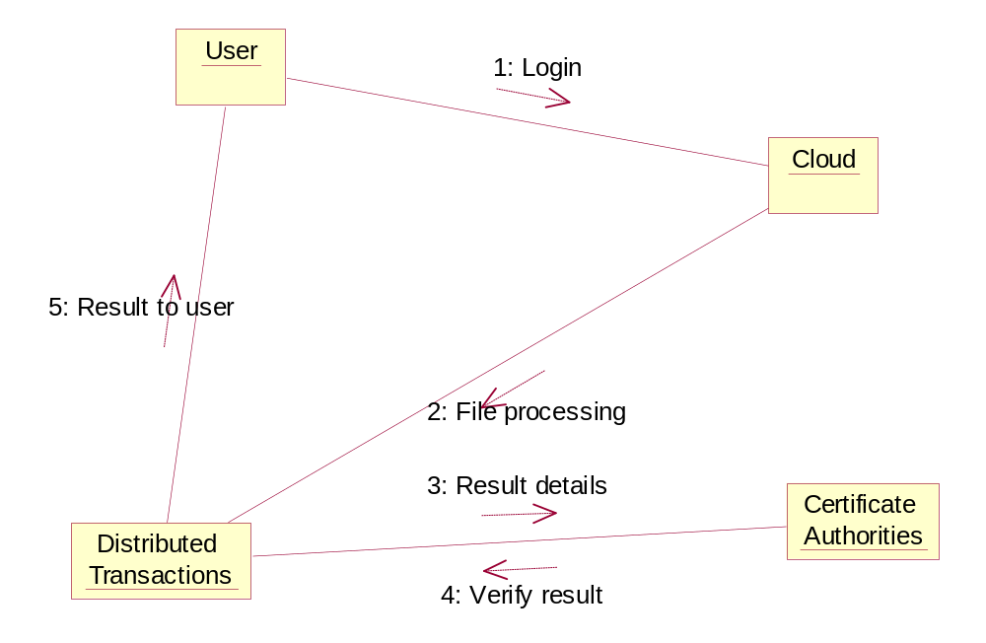

In this diagram source node find a destination by using dynamic routing if an attacker interrupts in that node they send a positive reply and malicious may be send to destination node. And then by an alert message broadcast to all nodes about attacker.

State diagram

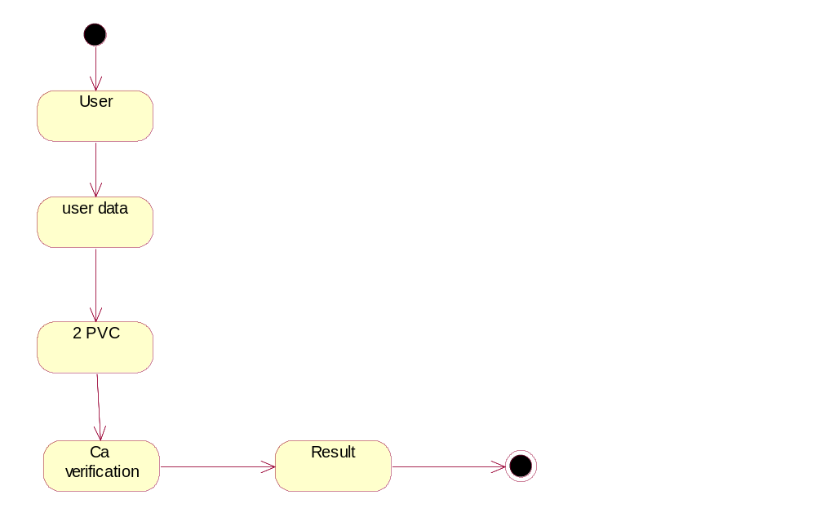

A state diagram is a type of diagram used in computer science and related fields to describe the behavior of systems. State diagrams require that the system described is composed of a finite number of states; sometimes, this is indeed the case, while at other times this is a reasonable abstraction. Here nodes are created then here tell about the maintaining node, then attacker interrupt and it causes network dysfunction.

ACTIVITY DIAGRAM
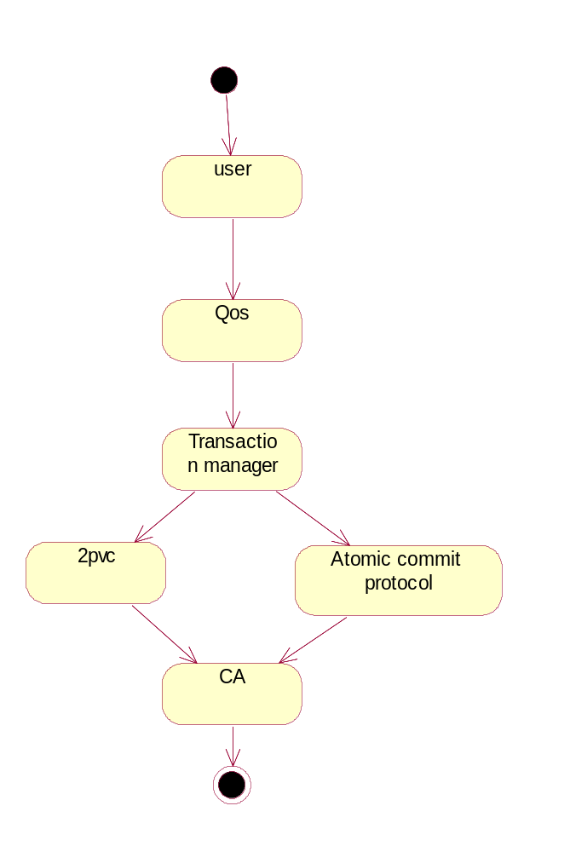

In this diagram first we have to create a network and path selection, the path that is dynamic at that attacker will interrupt in that network after attacker interrupt our system then we detect the attacker and prevent network. In this diagram represents the behavior of path selection and attacker.

COMPONENT DIAGRAM

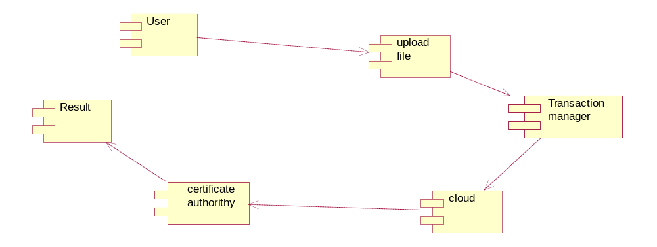

This diagram depicts how components are wired together to form larger components Java pack consists of number of nodes, in detection pack we detect the attack and prevent network.

DATA FLOW DIAGRAM
User
Check the user Data and also analysis
2 PVC
Receiver the result
Level-1

In this diagram we create a node, if node can send a message to another node at that time this network make a dynamic path selection, thus make a path selection for sending information to destination node. Every node has a neighbor node information and destination distance and send to receiver. At last the paths have been select and send to receiver.

Encrypt data
User
Name
E-mail id
password
Atomic protocol
2 PVC

Status
Result

E-R DIAGRAM

Here sender and receiver is an entity and then ipaddress, name and port are all attributes, then diamond box represents the relationship between the sender and receiver. This diagram illustrates the relationship between database and entity.

SYSTEM ARCHITECTURE

Transaction Management
User
Verify Credentials
Access Application
Verify Data
Encrypt Information
Store in Server
Token Generate
Transaction Management
User
Request Information
Generate Token
Verify
Decrypt Data
Forward to user
Step into Transaction Management

In this paper Interesting consistency problems can arise as transactional database systems are deployed in cloud environments and use policy-based authorization systems to protect sensitive resources. In addition to handling consistency issues among database replicas, we must also handle two types of security inconsistency conditions. First, the system may suffer from policy inconsistencies during policy updates due to the relaxed consistency model underlying most cloud services. In this paper, we address this confluence of data, policy, and credential inconsistency problems that can emerge as transactional database systems are deployed to the cloud. We define several different levels of policy consistency constraints and corresponding enforcement approaches that guarantee the trustworthiness of transactions executing on cloud servers we propose a Two-Phase Validation Commit (2PVC) protocol that ensures that a transaction is safe by checking policy, credential, and data consistency during transaction execution

FUTURE ENHANCEMENT
We identified several consistency problems that can arise during cloud-hosted transaction processing using weak consistency models, particularly if policy-based authorization systems are used to enforce access controls. We used workloads to experimentally evaluate implementations of our proposed consistency models relative to three core metrics: transaction processing performance, accuracy (i.e., global versus view consistency and regency of policies used), and precision (level of agreement among transaction participants). We found that high performance comes at a cost: Deferred and Punctual proofs had minimal overheads, but failed to detect certain types of consistency problems. And proofs were faster than view consistency ones in the few cases when the latest policy happens to match the policy used by all participating servers and as a result all servers skip the reevaluation step of 2PVC.

.
ADVANTAGE

- The number client can access server will not burden by using of 2PVC protocol
- It store secure data by using encryption algorithm.

CONCLUSION
Despite the popularity of cloud services and their wide adoption by enterprises and governments, loud providers still lack services that guarantee both data and access control policy consistency across multiple data centers. In this paper, we identified several consistency problems that can arise during cloud-hosted transaction processing using weak consistency models, particularly if policy-based authorization systems are used to enforce access controls. To this end, developed a variety of lightweight proof enforcement and consistency models—i.e., Deferred, Punctual, Incremental, and Continuous proofs, with view or global consistency—that can enforce increasingly strong protections with minimal runtime overheads.

REFERENCE OR BIBLIOGRAPHY

[1] M. Armbrust et al., “Above the Clouds: A Berkeley View of Cloud Computing,” technical report, Univ. of California, Feb. 2009.

[2] S. Das, D. Agrawal, and A.E. Abbadi, “Elastras: An Elastic Transactional Data Store in the Cloud,” Proc. Conf. Hot Topics in Cloud Computing (USENIX HotCloud ’09), 2009.

[3] D.J. Abadi, “Data Management in the Cloud: Limitations and Opportunities,” IEEE Data Eng. Bull., vol. 32, no. 1, pp. 3-12, Mar. 2009.

[4] A.J. Lee and M. Winslett, “Safety and Consistency in Policy-Based Authorization Systems,” Proc. 13th ACM Conf. Computer and Comm. Security (CCS ’06), 2006.

[5] M. Myers, R. Ankney, A. Malpani, S. Galperin, and C. Adams, “X.509 Internet Public Key Infrastructure Online Certificate Status Protocol - Ocsp,” RFC 2560, http://tools.ietf.org/html/rfc5280, June 1999.

[6] E. Rissanen, “Extensible Access Control Markup Language (Xacml) Version 3.0,” http://docs.oasis-open.org/xacml/3.0/ xacml-3.0-core-spec-os-en.html, Jan. 2013.

[7]D. Cooper et al., “Internet x.509 Public Key Infrastructure Certificate and Certificate Revocation List (CRL) Profile,” RFC 5280, http://tools.ietf.org/html/rfc5280, May 2008.
[8] J. Li, N. Li, and W.H. Winsborough, “Automated Trust Negotiation Using Cryptographic Credentials,” Proc. 12th ACM Conf. Computer and Comm. Security (CCS ’05), Nov. 2005.

[9] L. Bauer et al., “Distributed Proving in Access-Control Systems,” Proc. IEEE Symp. Security and Privacy, May 2005.

[10] J. Li and N. Li, “OACerts: Oblivious Attribute Based Certificates,” IEEE Trans. Dependable and Secure Computing, vol. 3, no. 4, pp. 340- 352, Oct.-Dec. 2006.

[11] J. Camenisch and A. Lysyanskaya, “An Efficient System for Non- Transferable Anonymous Credentials with Optional Anonymity Revocation,” Proc. Int’l Conf. Theory and Application of Cryptographic Techniques: Advances in Cryptology (EUROCRYPT ’01), 2001

[12] P.K. Chrysanthis, G. Samaras, and Y.J. Al-Houmaily, “Recovery and Performance of Atomic Commit Processing in Distributed Database Systems,” Recovery Mechanisms in Database Systems, Prentice Hall PTR, 1998.

[13] M.K. Iskander, D.W. Wilkinson, A.J. Lee, and P.K. Chrysanthis, “Enforcing Policy and Data Consistency of Cloud Transactions,” Proc. IEEE Second Int’l Workshop Security and Privacy in Cloud Computing (ICDCS-SPCCICDCS-SPCC), 2011.

[14] G. DeCandia et al., “Dynamo: Amazons Highly Available Key- Value Store,” Proc. 21st ACM SIGOPS Symp. Operating Systems Principles (SOSP ’07), 2007.

[15] F. Chang et al., “Bigtable: A Distributed Storage System for Structured Data,” Proc. Seventh USENIX System.

